Ahmad Kafaei’s designs

D:\1394 enhancement\v2\p2\z\landing page3.tif

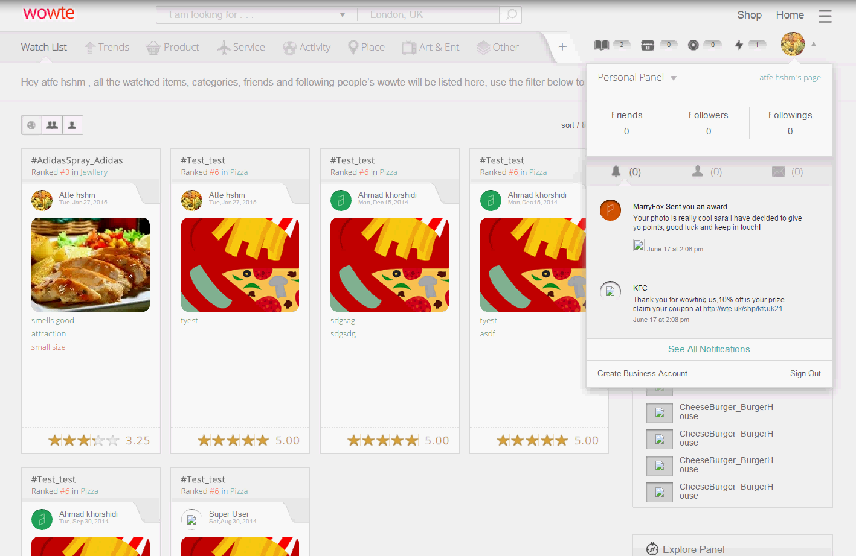

This is the screenshot of the project I have founded. The Idea, UI, UX was designed by me however later on after doing some research and interviwing targeted users I have found that it was a bit complicated and then re-designed it to a simpler and more user friendly site.

D:\old desktop\Front page\pic2.tif

The landing page of the wowte project

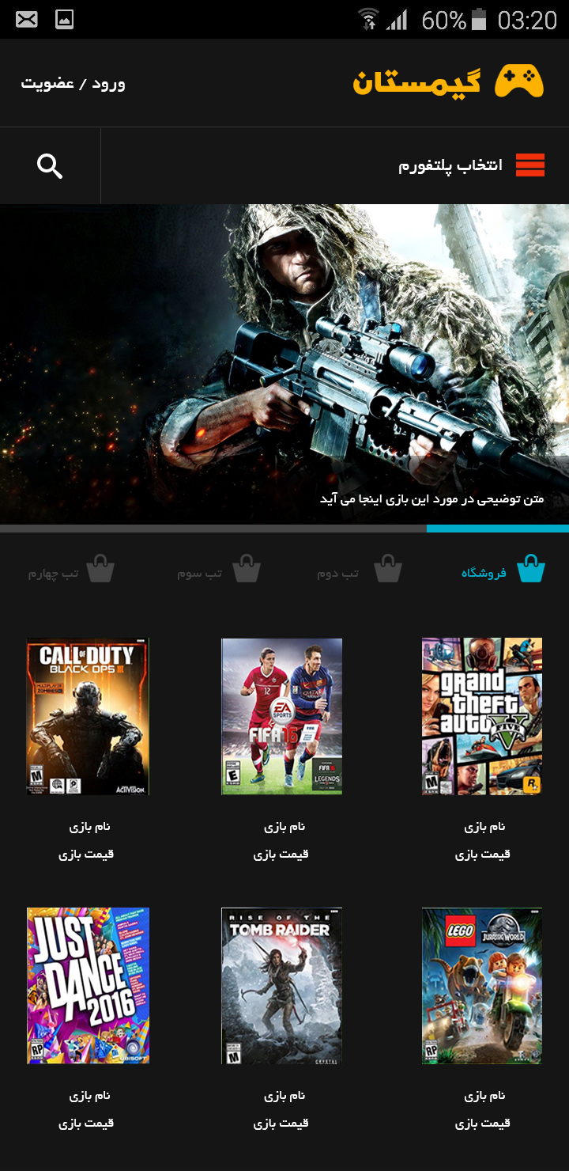

A contract project I have designed the UI with photoshop some years ago

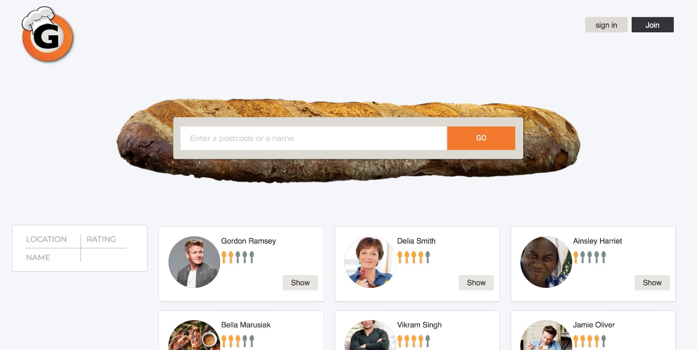

My idea of putting the search bar into the bread for our bootcamp group project (all the html, css and uiis done by me)

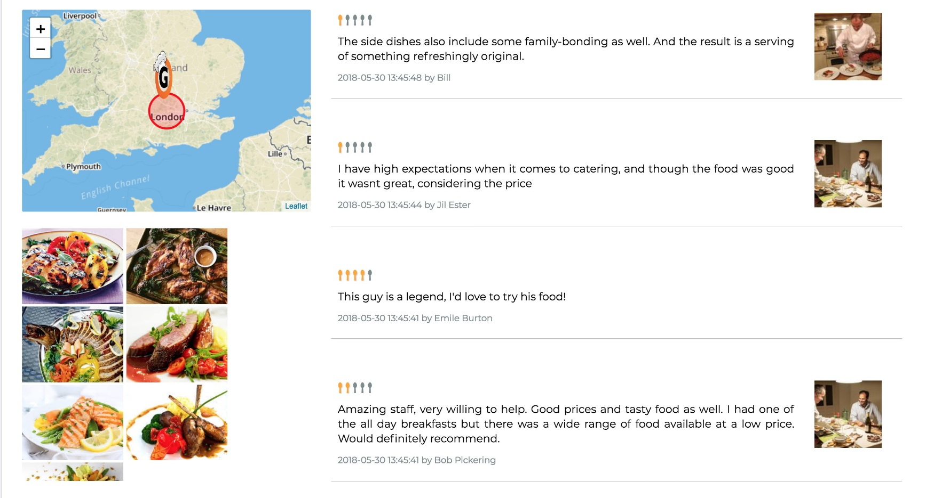

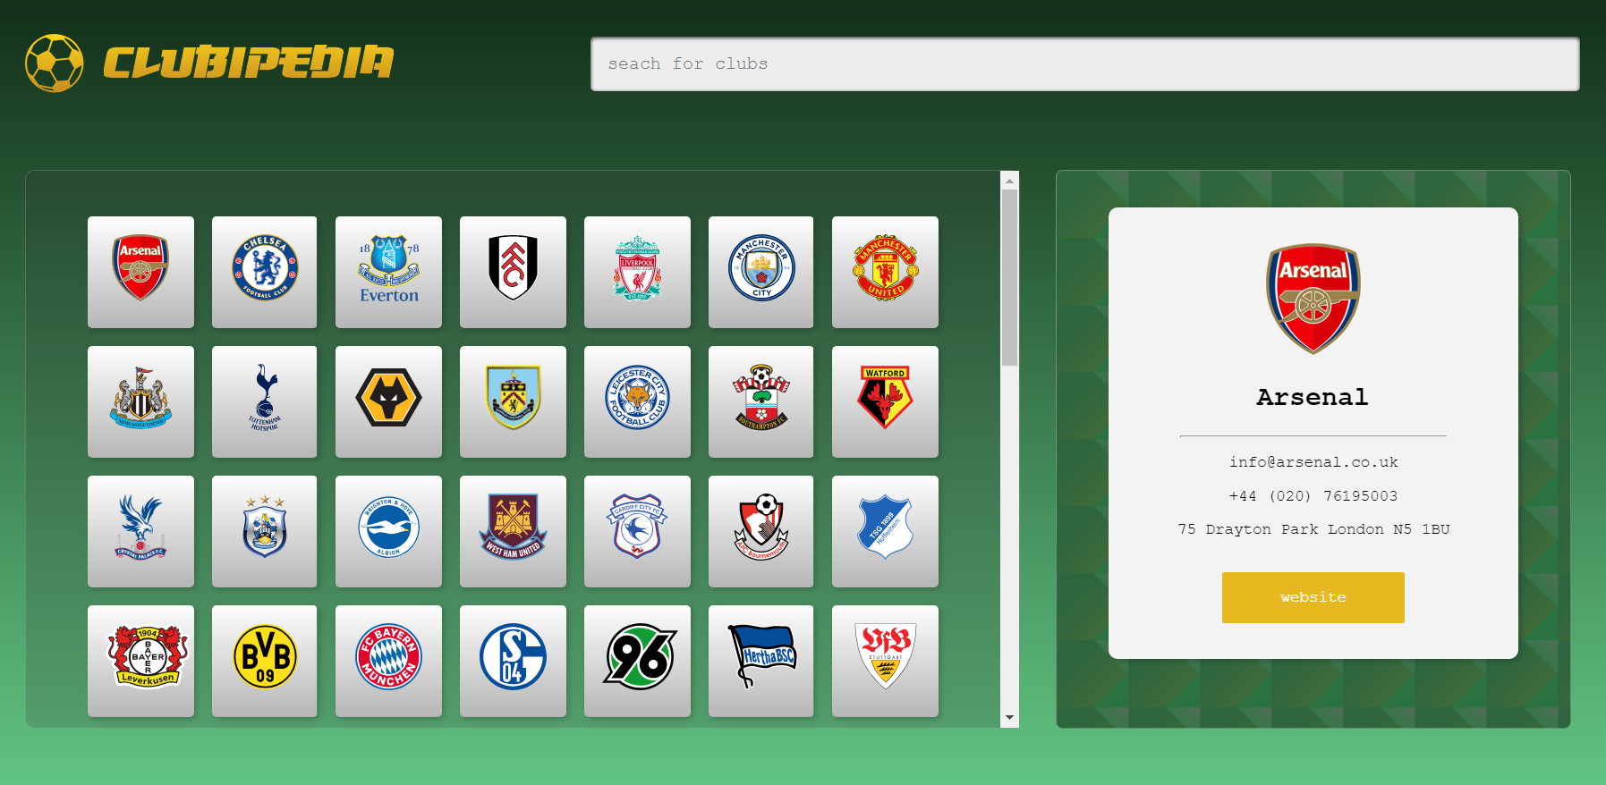

A simple react web app I created and designed